REPORT
Report of the Fellow who availed Fellowship / Training under Human Resource Development for Health Research.

1. Name and designation of Fellow : Dr Neelam Wadhwa Associate Professor
2. Address : Department of Pathology, UCMS & GTB Hospital, Delhi -110095.
3. Type of Fellowship and period : HRD Fellowship – Long term training in Indian Institute, 03.12.2014 to 02.06.2015
4. Duration of fellowship : 6 months
5. Frontline area of research in which : Modern Biology
Training /research was carried out
6. Name & address of mentor and host institute : Dr Anil Suri, Convener, Cancer Research Program, Cancer Microarray, Genes and Proteins Laboratory, Centre of Molecular Medicine, National Institute of Immunology, New Delhi -110067.
7. Highlights of work conducted :
i) Technique/expertise acquired : Annexure I (next page)
(Give in about 150 words)

ii) Research results, including any papers: None
prepared/submitted for publication
(Give in about 300 words)

iii) Proposed utilization of the experience
in the Parent Institute. (Please specify the project developed whether originally proposed/ new project) : Will be submitted shortly

Signature of Fellow

ANNEXERUE I – Techniques/ expertise acquired

Dr Suri’s laboratory ‘Genes and Proteins Laboratory’ is actively engaged in research on role of cancer testis antigens (CTA) in human malignancies. During my stay at Dr Suri’s laboratory I learnt about role of spag-9 gene, a novel CTA in various cancers as part of his several ongoing research projects.
Models of learning: In-vitro and in-vivo, hypothesis testing
In-vitro models: Cell cultures of various tissue malignancies
In-vivo models: Mice
Hypothesis testing model: Gene knock down by shRNA (short hairpin RNA)
Techniques learnt:
Cell culture handling
Techniques used in proteomics: Protein extraction from cell lines and tissues, quantification, SDS-PAGE, Western blotting, Indirect immnunofluorescence.
Techniques used in genomics: Nucleic acid extraction from cell lines and tissues, cDNA synthesis, PCR, Real time PCR, Agarose gel reading.
Cell assays of various types: Cell proliferation, apoptosis, viability, migration and invasion, colony forming, wound healing.
E. coli transformation and plasmid propagation.

Scientific Report in Detail

Ref No: DHR/HRD/Fellowship/III (1)/13-14 dated 05.11.2014

Fellow: Dr Neelam Wadhwa
Mentor: Dr Anil Suri
Place of fellowship: National Institute of Immunology, Delhi.
Period of fellowship: 03.12.2014 to 02.06.2015

Dr Suri’s laboratory ‘Genes and Proteins Laboratory’ is actively engaged in research on role of cancer testis antigens in human malignancies. The laboratory is credited with characterization of a novel testis specific antigen ‘sperm associated antigen 9 (spag-9)’. The pathologic distribution of spag-9 has been shown to be restricted to cancers; in health only gonadal calls express the antigen. This makes spag-9 an attractive molecule for therapeutic targeting. During my stay at Dr Suri’s laboratory I learnt about role of spag-9 gene in various cancers as part of his several ongoing research projects.

CELL CULTURE TECHNIQUES

Cell culture handling
The cells were cultured in complete DMEM and passaged at 80-90% confluency using trypsinization and PBS wash. Gene knock down was performed at 60-70% confluency to target actively dividing cells. Freeze downs were prepared using DMSO as cryo-preservant.

Gene knockdown by shRNA
Target gene expression was suppressed using shRNA. Transient transfection was done using lipofectamine technique. The transfection procedure was performed at 60-70% confluency for higher efficiency. Cell lysates were prepared after 48 hours of procedure. Transfection was checked by Western blotting and PCR.

TECHNIQUES FOR PROTEINS

- Western blotting
- Indirect immunofluorescence
- Immunohistochemistry

Western Blotting

Sample preparation
Cell lysis
Cells were lysed using cell lysis buffer and appropriate amount of protease inhibitor cocktail. The supernatant was collected after centrifugation at 4C.

Protein concentration determination
Protein concentration was determined by BCA (bicinchoninic acid) assay. BCA working solution was prepared by mixing solution A and B in ratio of 50:1. Cell lysate was mixed with working BCA solution in ratio of 1:20. After incubating at 37C in dark x 30 minutes, the absorbance was recorded at 562 nm in a micro-titre multi-plate ELISA reader. Serial dilutions of bovine serum albumin were used to obtain the standard curve. The cell lysate protein concentration was extrapolated from the standard curve.

Vertical gel electrophoresis
SDS-PAGE was performed on cell lysate for resolution of protein bands by their molecular weight. In this method, vertical gel electrophoresis is run in reducing and denaturing condition making the protein movement directly in proportion to their molecular weight and independent of their other properties. Equal amounts of proteins mixed with loading dye were dispensed into wells; pre-stained protein ladder was used in each run. The run was conducted at 120 volts till the dye exited the gel. Coomassie staining was performed for visualization of protein bands (Figure 1).

Figure 1:
Coomassie stained SDS-PAGE gel showing several bands (sample: E coli having carrying carrier plasmid for spag 9 gene)

Western blotting
Western blotting was performed to detect and semi-quantify the protein of interest. This involves 2 steps: transfer to PVDF membrane and sequential probing with specific antibodies and detection by colorimetric or chemiluminiscence method. Coomassie dye staining step was omitted for western blotting.

Transfer to PVDF membrane
Wet transfer was performed for better results. The gel and PVDF membrane (0.45um) were placed in a supported sandwich with gel near the cathode (negative) end. Being negatively charged the proteins migrate towards positive end. The run was conducted at 100 mA x 90 minutes in cold conditions. Ponceau S staining was used for assessing transfer.

Immuno-blotting
The membrane was treated with blocking reagent (3% skimmed milk in PBS) x 30 minutes. Overnight incubation with appropriately diluted primary antibody was done at 4C. Next day, the membrane was probed with HRP (horse radish peroxidase) enzyme conjugated secondary antibody. Signal detection was done using DAB as chromogen or enhanced chemiluminiscence (ECL) method. Wash performed in between using PBS/ PBS-T as appropriate (Figure 2).

Figure 2:
Western blot – ECL (enhanced chemiluminescent) reagent exposed X-ray film. Cell lysates from single sample of mice tumor xenograft exposed to different primary antibodies (lane 1- spag 9, lane 5 – PCNA, lane 6- beta catenin).

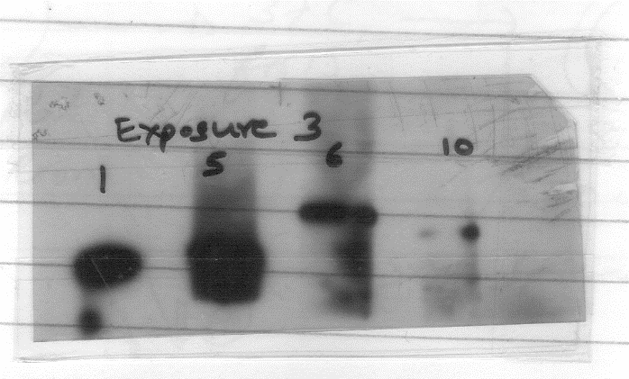

Indirect Immunofluorescence
The cells were cultured on coverslips and paraformaldehyde fixed. Cells were exposed to blocking antibody, followed by overnight incubation with primary antibody. Fluochrome labelled secondary antibody incubation was followed by DAPI counterstaining. Cells were visualized on a fluorescent microscope using appropriate filters.

Immunohistochemistry
Sections were obtained on lysine coated slides. The dewaxed hydrated sections were subjected to antigen retrieval in citrate buffer (pH 6.0) followed by peroxidase block. This was followed by sequential probing with blocking antibody, primary antibody and HRP enzyme conjugated secondary antibody. Signal detection was done using DAB chromogen and hematoxylin counterstain. Washes were performed in between steps with PBS.

TECHNIQUES FOR NUCLEIC ACIDS

DNA and RNA were isolated from cells and amplified using validated primers. Quantification of gene expression was done by RT-QPCR.

Nucleic acid extraction, quantification and quality check
Guanidine-isothiocyanate based commercial kits were used for RNA extraction. RNA was quantified by optical density at 260 nm and its quality was checked by 1% reducing agarose gel electrophoresis using MOPS buffer at 80 volts. For DNA extraction phenol chloroform method was followed (Figure 3).

Figure 3:
Agarose gel (0.7%) electrophoresis of plasmid DNA isolated from E coli by manual (alkali lysis) method prior and after RNAse treatment.

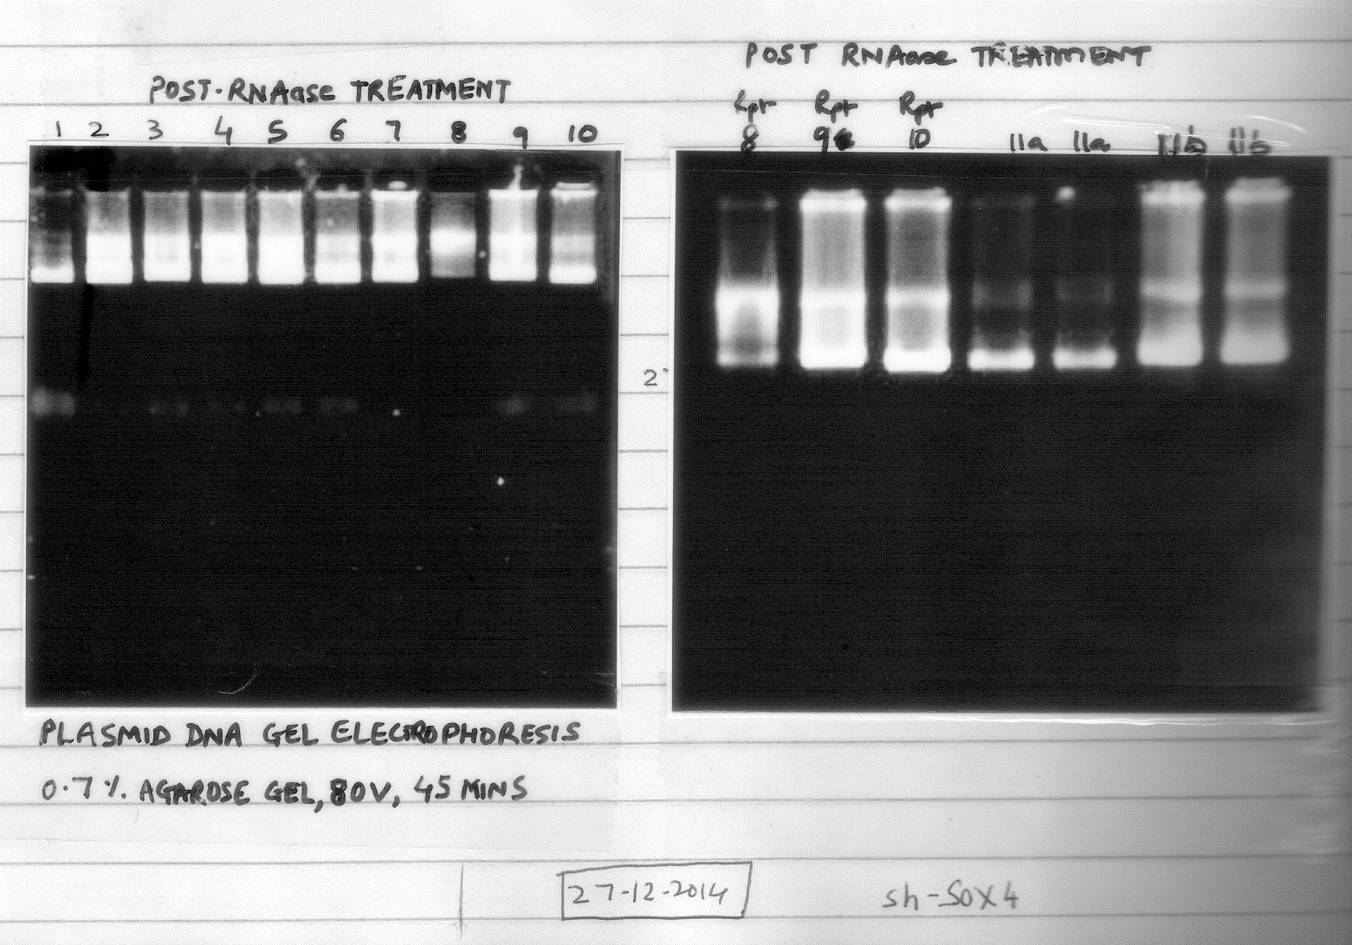

cDNA synthesis (RT-PCR)
500 ng RNA was converted to cDNA in 20 uL reactions carried out in RNAse free laboratoryware. The results were checked by 1% agarose gel electrophoresis with 0.5% TBE running buffer.

Q-PCR
SYBR green method was followed; beta actin served as housekeeping gene. Relative quantification was performed using commercial software. Expression of downstream genes were studied after gene knockdown and compared to control cells. Several down-stream genes were studied, such as those involved in cell cycle, apoptosis, cell proliferation, epithelial mesenchymal transition.

CELL ASSAYS

The effect of target gene knock down was studied on various cell properties. The assays learnt include:

Apoptosis assay by M30 – it detects presence of cleaved cytokeratin 18 in apoptotic cells. Harvested cells were incubated with M30 antibody and results acquired in flowcytometer.

TUNEL assay – it detects inter-nucleosomal DNA fragmentation, which is a hallmark of apoptosis.

Propidium iodide assay – It is an intercalating agent and fluorescent molecule. Only dead cells are stained as live cells are impermeable to the dye. RNAse treated cells are tested by flowcytometry.

MTT viability assay – It is a cell viability assay as only metabolically active cells reduce MTT to formzon which is then solubilized to assess cellular viability at 574 nm.

Senescence assay – It is histochemical test for beta galactosidase enzyme. The enzyme is expressed only in senescent cells. Blue green stained cells are counted after fixed cells are treated with staining mixture containing enzyme substrate.

Cell proliferation assay – Small number of cells are allowed to grow in excess cell culture medium. The effect of gene knockdown is assessed by comparing cell proliferation with untreated cells.

Colony forming assay – it tests the clonogenic potential of cells and uses extremely small number of cells which are allowed to grow for upto 10 days. Colony count is done by staining with 0.5% toluidine blue.

Migration invasion assay – These tests measure the motility and invasion of cells and hence reflect the potential local invasion and metastasis capacity. Cells suspended in incomplete culture medium migrate towards complete medium through a sterile inert mesh insert. Difference between treated and untreated cells are compared by counting number of cells in complete medium at several time points. For invasion assay, the mesh is coated with matrigel, a commercial extracellular matrix mix, to mimic in vivo invasion.

Wound healing assay – The ability of cells to grow back in artificially created wound (by scratching) in cell culture is a measure of cell migration. The time to fill the gap is compared between treated and untreated cells.

IN VIVO DISEASE MODEL

Animal models are used to corroborate and validate results obtained during in-vitro experiments. Tumor xenografts were analysed by techniques similar to those described earlier.

PLASMID VECTOR PROPOGATION IN E COLI

The shRNA constructs are propagated in E coli to obtain their large quantities. First the bacterial cells are made competent, i.e. capable of undergoing transformation. The vector often uses antibiotic resistance as an accompanying insert to identify transformed bacteria. Such bacteria were cultured in antibiotic selective media to harvest large amounts of plasmid. The plasmid DNA was then isolated by either commercial or EDTA-alkali denaturation neutralization based method. Thus isolated plasmid DNA was used for transfection/animal models.

During my stay at Dr Anil Suri’s laboratory, I have learnt about these techniques. I also had the privilege of getting hands on experience for some techniques. My interactions with Sir and his team members especially Dr Nirmala Jagadish were encouraging and academically stimulating.

